Pointillism Art with Q-tips and Watercolors

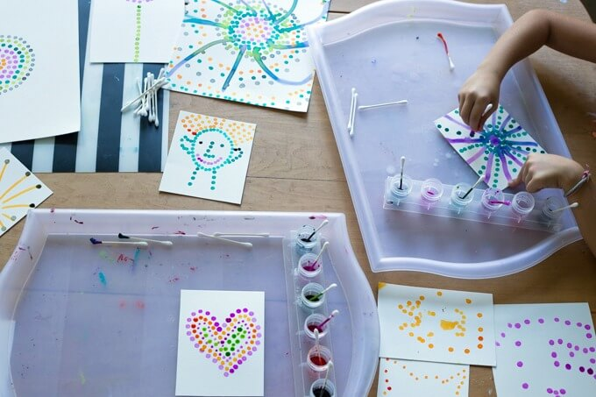

MATERIALS
- Liquid watercolors*
- Watercolor paper
- Q-tips (or other cotton swabs)
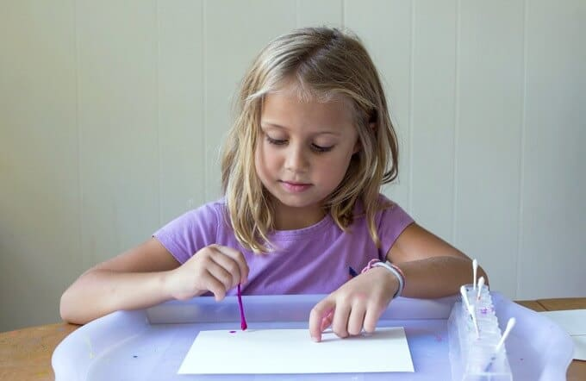

SET-UP
Set up the activity on a tray or mat with a sheet of watercolor paper and your watercolor paints in individual dishes or cups with a Q-tip or cotton swab for each color.
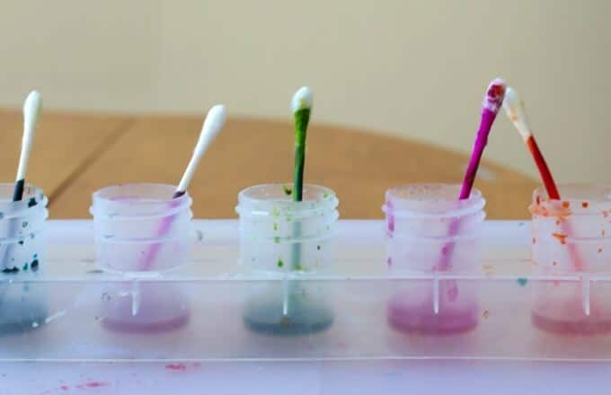
We like these paint cups in a base for liquid watercolor paints, but you can use individual cups, too.

The paper can be used whole or you can cut it into smaller pieces if you like. We found that half and quarter sheets work well with Q-tip pointillism.

INSTRUCTIONS
Dip a Q-tip in one of the liquid watercolors, then press the tip to the paper.
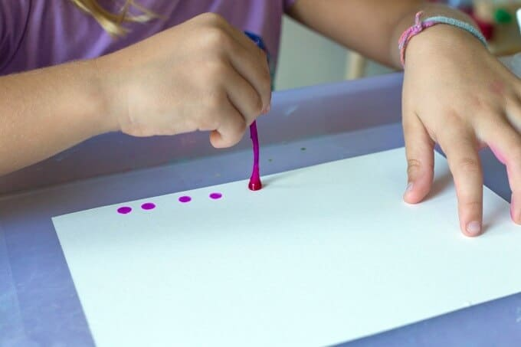
And again. You can get a number of dots out of one paint dip. When the color is starting to fade, dip the Q-tip in the paint again before pressing it to the paper. Or use a new Q-tip and a different color of paint.
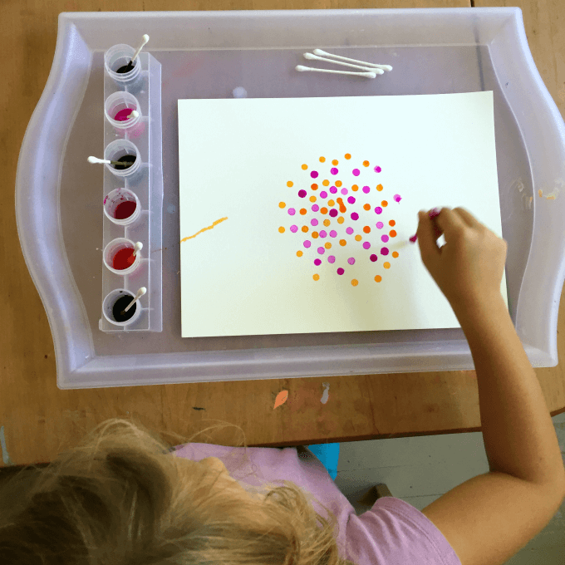
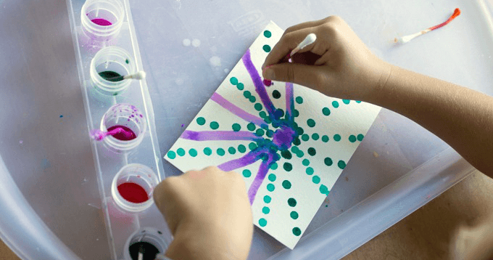
(The Q-tips make great dots, of course, but they also work well as paint brushes for lines and such.) Let the artwork dry.
