Coffee Filter Butterflies
Here’s what you’ll need:
- 2 coffee filters
- Washable markers (we used Mr. Sketch, but Crayola will work too)
- Water
- An eye dropper or small measuring spoon
- 1 pipe cleaner (12″ long)
You will need TWO coffee filters for this craft. Place one inside the other so they fit together well. We used the coffee filters meant for small 4 to 6 cup coffee makers.

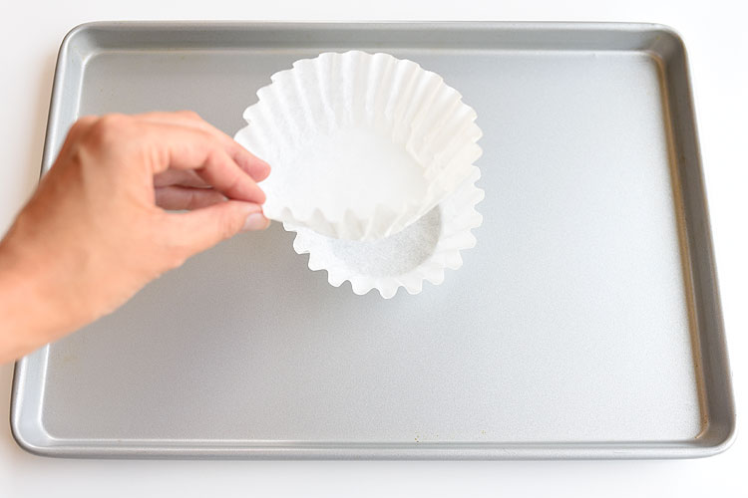
Flatten out the coffee filters a little. They don’t have to be perfectly flat, just flat enough that you can color on them.
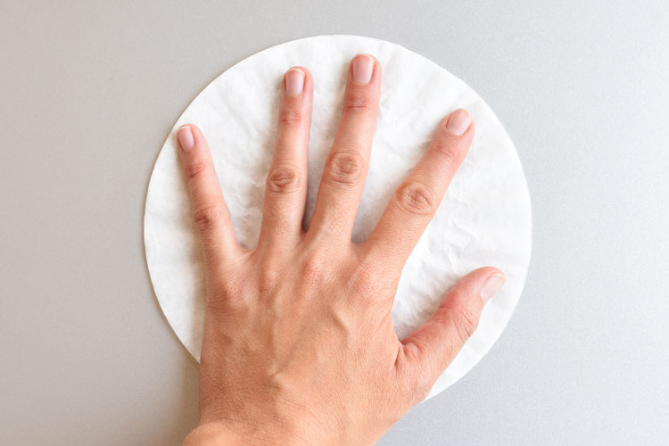
Color your creative designs onto the coffee filters. You’ll be coloring on 2 layers, and some of the marker will leak through to the bottom coffee filter.
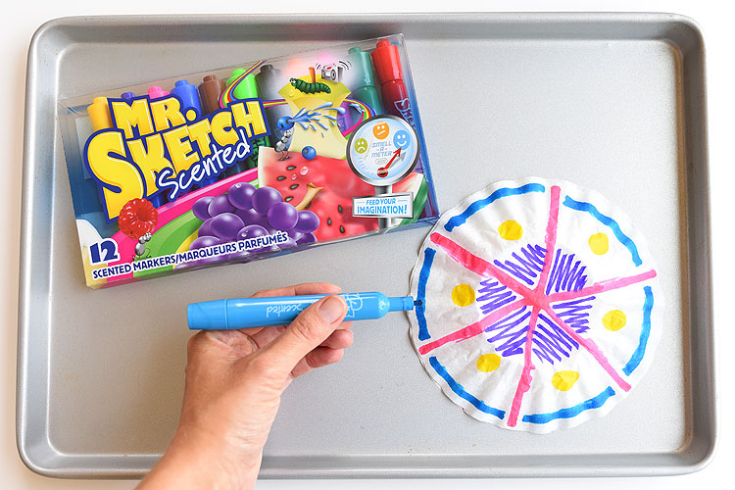
Then place your coffee filters into a circular foil pan. Take an eye dropper or small measuring spoon and drip water onto the marker until the coffee filter is completely wet. Once the coffee filter is completely wet, stop adding water. If you add a big pool of water the colors will mix together too much, plus it will take forever to dry.
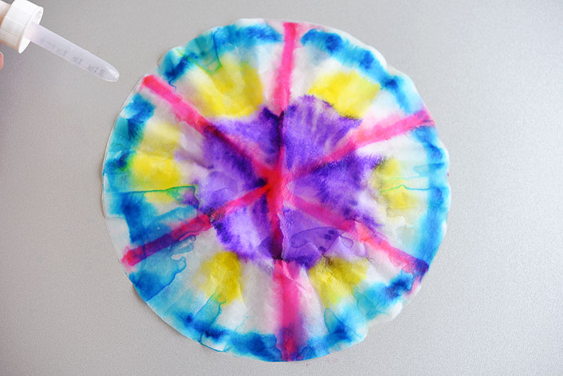
Place foil pan and a volunteer will dry these with a blowdryer
Use this time to read a book found in your supply box or show a youtube video: The Very Hungry Caterpillar - Animated Film - YouTube
Once they are dry and you pull apart the two coffee filters, you will end up with two very similar looking layers.
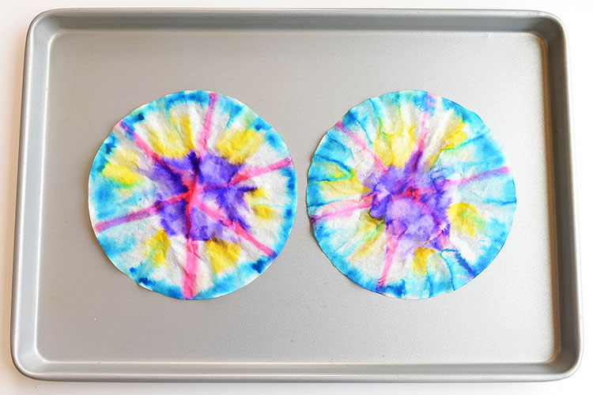
Fold each one back and forth, accordion style, in about 1/2″ folds. (Just make sure the coffee filters are completely dry first or you’ll end up with messy fingers!)
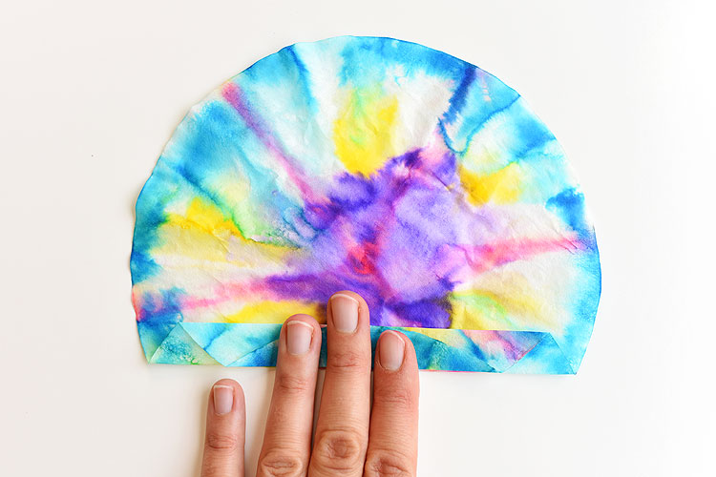
Keep folding until the end, so you have two strips that look like this:
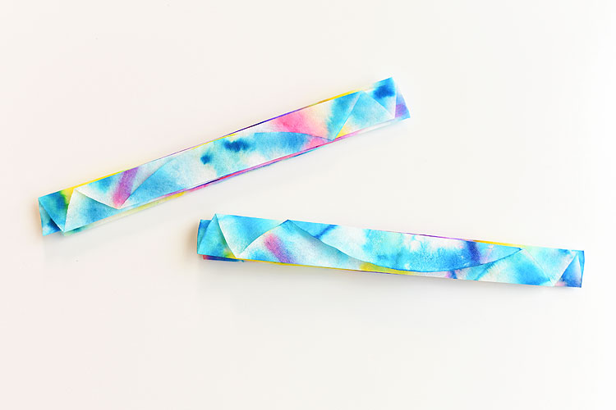
Put the two folded strips on top of each other.
Twist a pipe cleaner around the middle so that the two ends point upwards in a big letter “V”. Trim the ends to make them even if you need to.
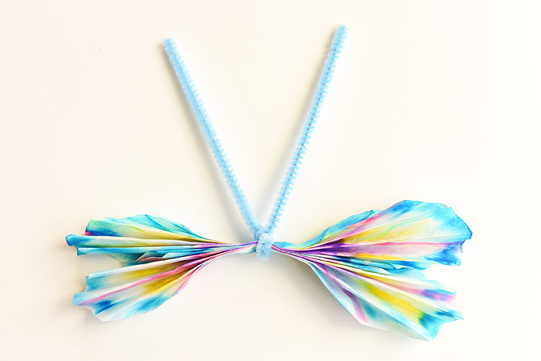
Next, pinch the end of each pipe cleaner and curl it outwards to make a small spiral.
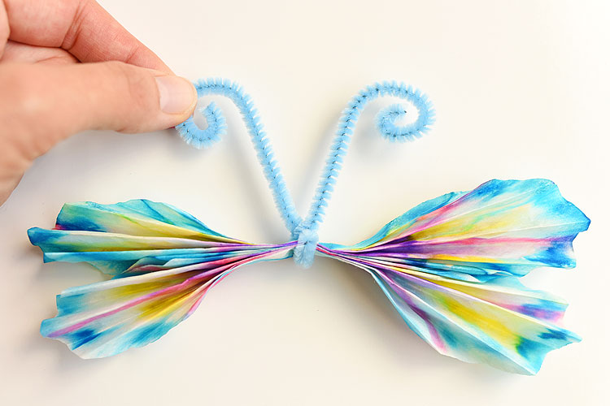
Finally, pull apart the folds in the coffee filter to open them up and shape your butterfly.
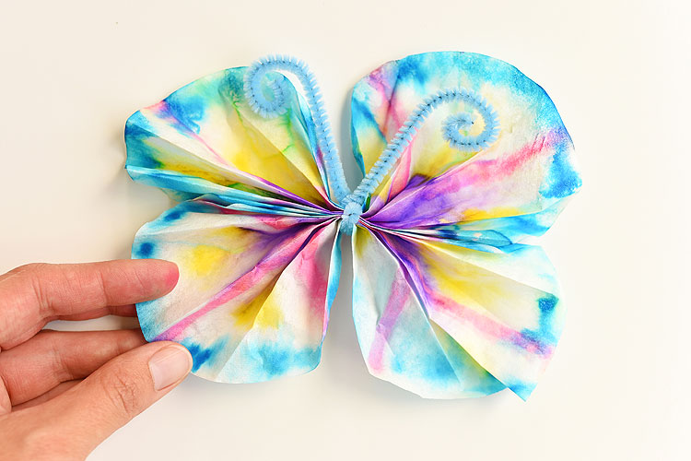
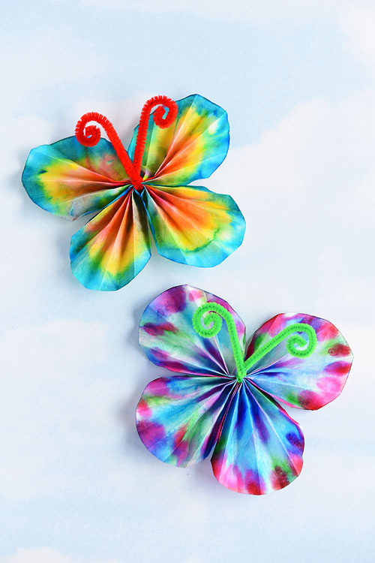

My little tip:
The less white space you leave on the coffee filters, the brighter your butterflies will be. I recommend coloring more of the coffee filter with marker than what I showed in the tutorial photo above.
Just make sure you leave at least a little bit of white space between the colors (about 1/4″). My 6 year old daughter covered her entire coffee filter with dark marker with zero white space and made a butterfly that was almost all navy and black… still pretty, but not quite what we were going for!
