Faux Stained Glass Suncatcher Craft for Kids

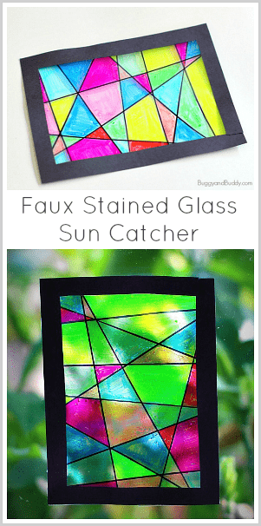

Materials for Faux Stained Glass Suncatcher Craft
- Ink-jet transparencies (Inkjet transparencies have a rough side that works with the highlighters. Regular transparencies won’t work for this specific project.)
- Scotch tape
- Highlighters in a variety of colors
- Black Sharpie
- Ruler or other straight edge
- Scissors
- Double-sided tape or liquid glue
- Construction paper or cardstock for frame

Directions for Making Faux Stained Glass Suncatcher Craft
1. Cut your inkjet transparencies to the size you’d like your suncatcher to be.

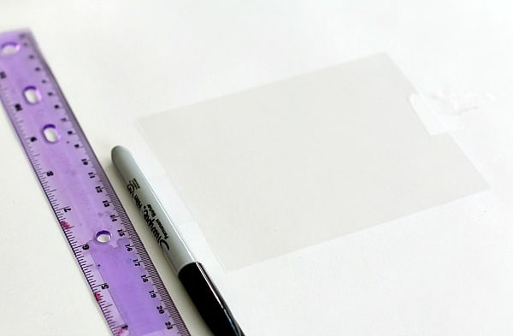

2. Your transparency has a rough side and a smooth side. Tape it down with a few pieces of tape so the smooth side is face up.
3. Use your black Sharpie and ruler to draw numerous intersecting lines across your artwork so it resembles a stained glass pattern.

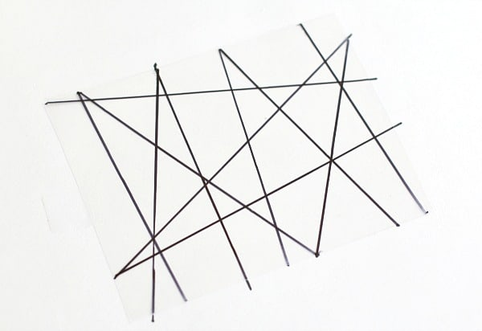
4. Turn your transparency over so the rough side is face up. Use your highlighters to color in the areas formed by the intersecting lines. Let it dry.
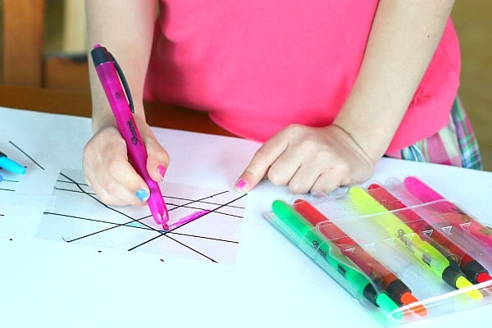

5. Cut out a frame from your construction paper and use double sided tape or glue to adhere it to your artwork.

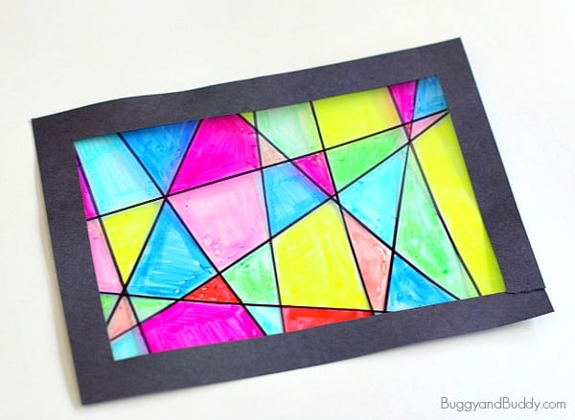

6. Hang it up in a window!

