Splat Owls

THE SUPPLIES YOU NEED:
To recreate this Paint Splat Owl Face tutorial, I used white, as well as orange cardstock, my trusty & favorite Tulip Puffy Paint, scissors, glue and some large wiggle eyes.
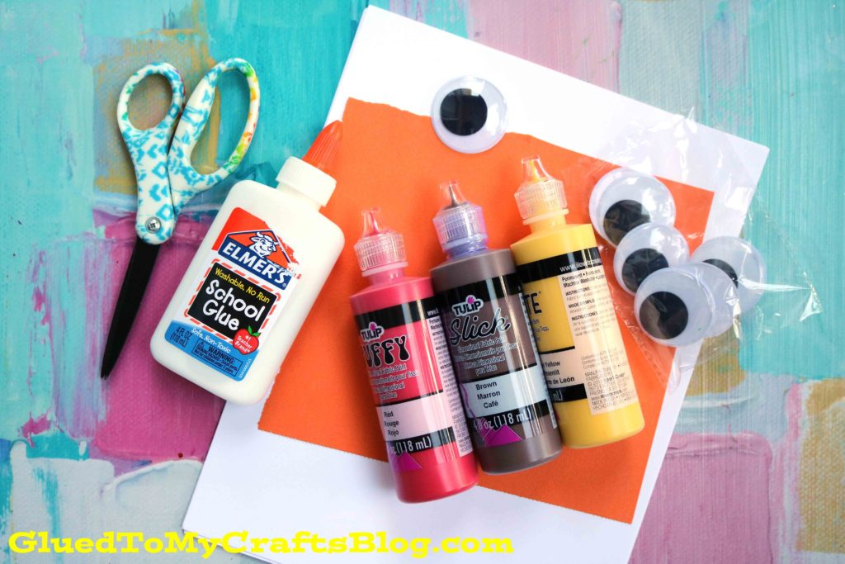

THE SIMPLE DIRECTIONS:
So let’s start! Just fold your white cardstock in half, open back up and squirt CIRCLES of red/brown/yellow paint colors ON ONE SIDE before closing up the white cardstock again. {I normally say you can make ANY design you like but a CIRCLE design is very important for today’s craft!}
Once the paper is closed for the second time, gently take your hand and “caress” the paint around inside, so it makes a fun symmetrical “owl head” print design on both sides of the paper {keep in mind – paint might ooze from the sides of the cardstock, so be sure to work in an area that can get dirty!}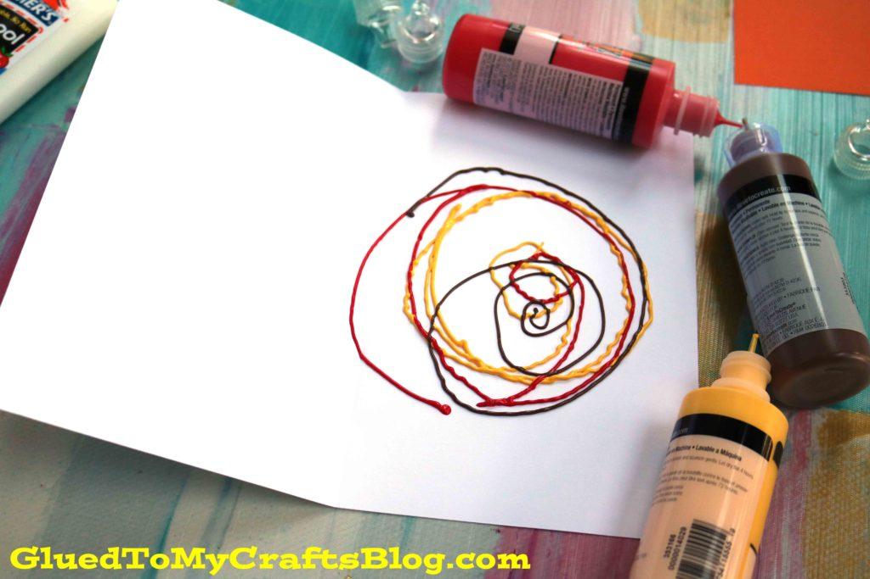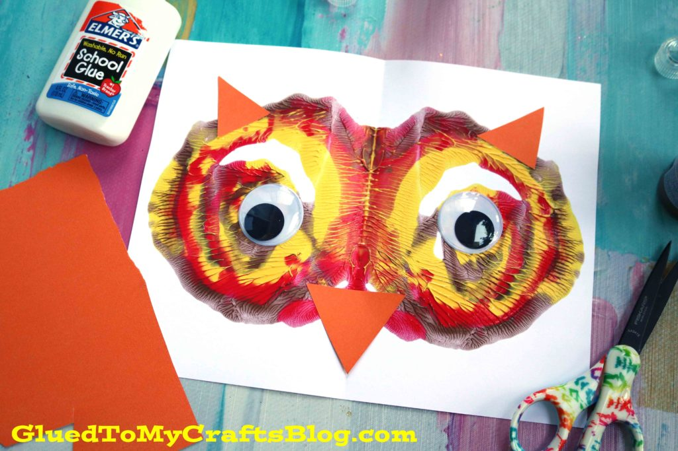
Now you are ready to open it back up and see the BEGINNING of what your owl’s face will be.
Next up, grab your colored cardstock and your scissors. Cut out TWO triangular ears and a triangle nose. Glue those to your painted cardstock piece.
Add on the large wiggle eyes.
Once finished with your custom owl masterpiece, set aside to let it dry completely, before displaying proudly! And of course – repeat as many times as you like! No two pieces will be the same and I think that’s what makes it even more fun!

