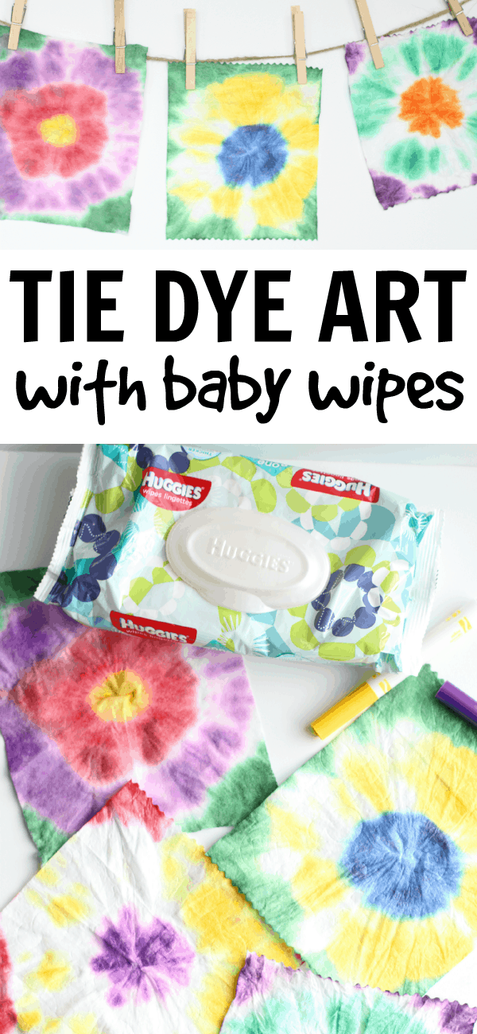
Here’s what you’ll need:
- Baby Wipes
- Rubberbands
- Washable Markers and/or Liquid Watercolors
- Paper towels
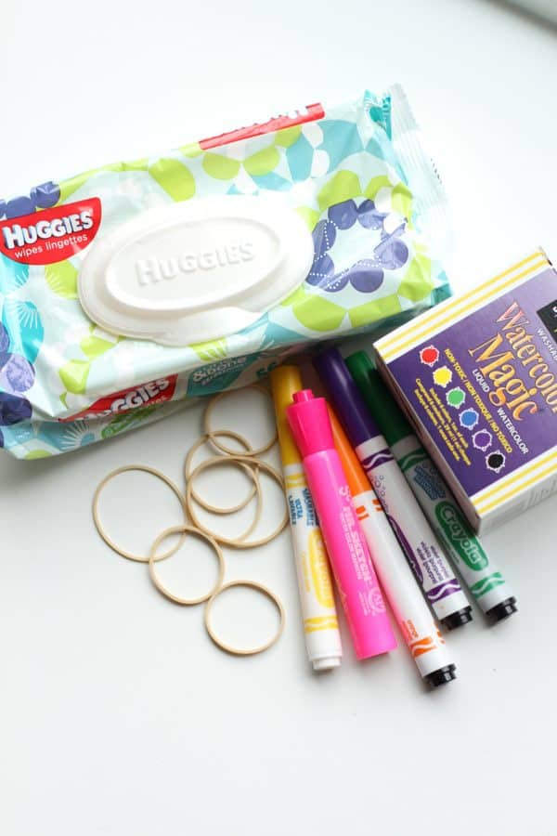
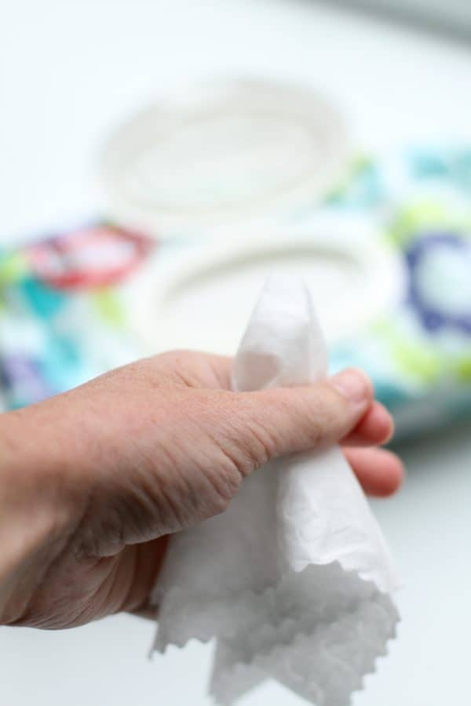
1. Pinch the center of the baby wipe and hold in your hand.
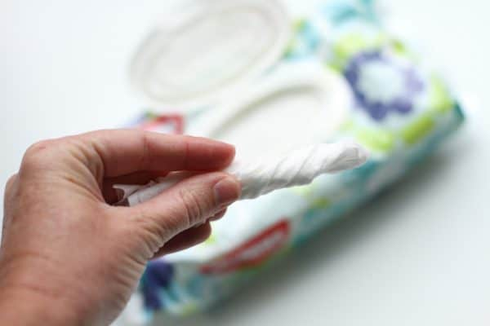
2. Twist.

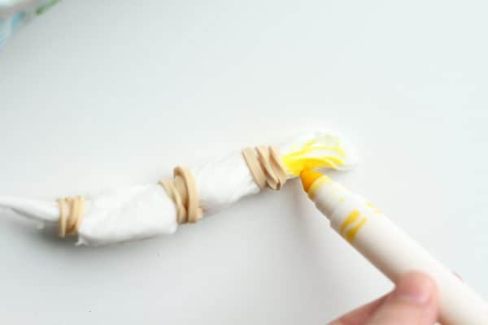
3. Carefully attach a few rubber bands and have your child use a marker to color the sections of the baby wipe.
The more that the marker gets into the folds, the more vibrant the color will be.

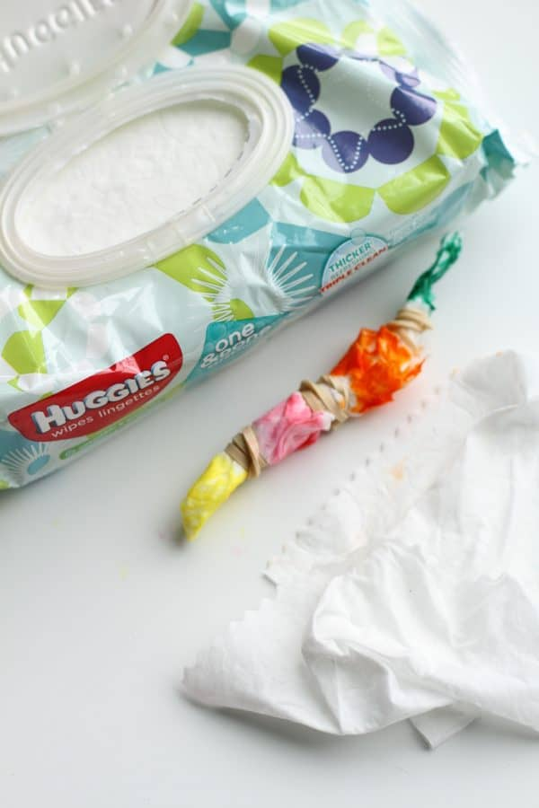
Continue using other colors of markers to complete the tie dye baby wipe. Not pictured: Remove the rubber bands, gently unfold the baby wipe and lay on top of two pieces of paper towel until it has completely dried.

